Quadrupedal Locomotion
Total chapters- 9 + Appendix
This book gives us a general idea on 4 legged robots and then proceeds to document a robot named
SILO4 - https://www.youtube.com/watch?v=JTFH8AKnGAM

A. Walking algorithms

Ch.1 – Walking Robots
This chapter discusses the history, advantages & disadvantages of walking locomotion and its potential/real uses.

Ch. 2 – Stabiliy in walking robots
The exact definition of stability of a walking robot was developed over time.
An ideal robot is statically stable if the horizontal projection of its center of gravity (COG) lies inside the support polygon( Support polygon is a polygon that is made by joining the endeffectors of a walking robot.)

i. Static Stability Criteria: The Center of Gravity Projection Method claims
that the vehicle is statically stable if the horizontal projection of its COG lies
inside the support polygon (defined as the convex polygon formed by connect-
ing footprints).

The Static Stability Margin (S_{SM} ) is defined for a given support polygon as the smallest of the distances from the COG projection to the edges of the support polygon. S_{SM} is the optimum
stability margin for an ideal machine on horizontal, even terrain. However,
the equation for calculating S_{SM} is complex.

So, S_{LSM} was proposed. It defined as the smallest of the distances from the COG projection to the front and rear edges of the support polygon along the machine’s longitudinal axis.

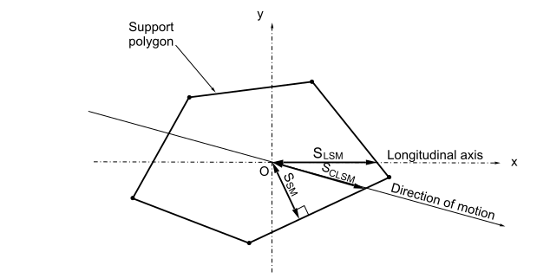

Later, Crab Longitudinal Stability Margin (S_{CLSM} ) was defined. S_{CLSM} is the smallest of the distances from the COG projection to the front and rear edges of the support polygon along the machine’s motion axis.

A better stability measurement called Energy Stability Margin (S_{ESM} ) was proposed.
It is defined as the minimum potential energy required to tumble the robot around the edges of the support polygon
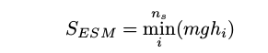

Finally, a normalised S_{ESM} i.e. S_{NESM} was proposed. It is defined as:
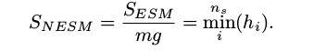

S _{N ESM} was shown to be the most efficient stability margin for statically
stable walking machines. However, when dynamic effects arise during walking,
machine stability cannot be judged precisely. Such situations exist in real
walking robot applications, and therefore dynamic stability margins are more
suitable.

ii. Dynamic Stability Criteria:
The Center of Pressure (COP, aslo called effective mass centre) Method claims that a robot is dynamically stable if the projection of the COG along the direction of the resultant
force acting on the COG lies inside the support polygon.

The Dynamic Stability Margin is thus defined as the smallest distance from the COP to the
edges of the support polygon.

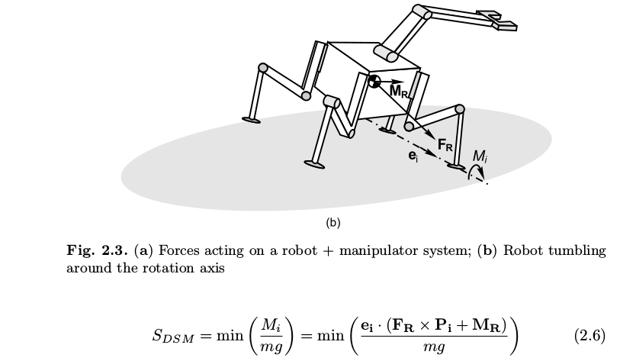

Normalized Dynamic Energy Stability Margin, S _{N DESM} accurately quantifies robot stability accurately on uneven terrain in the presence of manipulation dynamics and external perturbations.


E_{i} stands for the stability level of the i-th side of the support polygon.

Comparative study of different stability criterias:
Tick denotes that the stability criteria is valid
Cross denotes that the stability criteria is invalid
* denotes that the staboilty criteria is best suited for the given condition
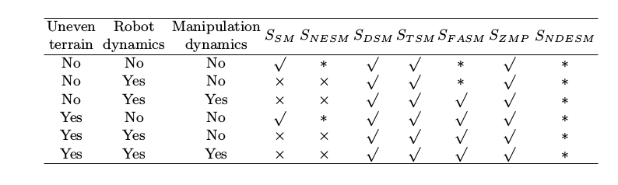

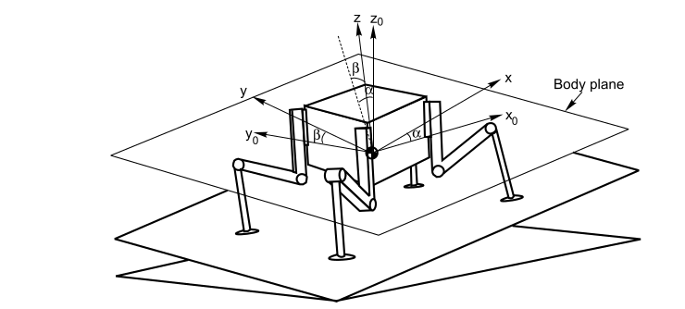

x, y, z - external reference frame
x0, y0, z0 – body reference frame

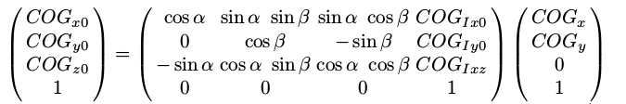
Relation between external and body reference frames:

Ch. 3 – Generation of Periodic Gaits:

Continuous Gaits
This section discusses the wave gait.
The following definitions are required to formulate a gait:
i. The duty factor, β , of leg i is the fraction of the cycle for which it is on the ground.
ii. The leg phase of leg i, Φ , is the normalized time by which
the placement of leg i on the ground lags behind the placement of leg 1
iii. The leg stroke, R, is the distance which a foot is moved rela-
tive to the body during the support phase.
iv. The stroke pitch, P , is the distance between stroke centers
of the adjacent legs.
v. The stride length, λ, of a gait is the distance travelled by
the center of gravity COG of the body along a locomotion cycle. If the gait is
periodic then λ= R/β

Wave gait has following parameters:
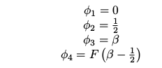

Discontinuous Gaits:

One leg is transferred with all other legs in support and halted. The body is propelled with all legs in
support and moving simultaneously.

Ch. 4 Generation of Non-periodic Gaits

Free crab gait and turning gaits are discussed in this chapter. Math & algo for these gaits is nicely derived.
Note- Recommend to read this chapter completely from the book

Ch. 5 -New Approaches to Stability

We have studied different static and dynamic stabilty margins. Those margins were based on either geometric or energetic measurements assuming ideal actuators. Real motors are torque limited. So, we have to considers the influence of different torques while quantifying stability of the robot.

Effects of Considering a Limited Motor Torque:
The main idea was to observe the robot’s behavior while traversing a straight
line without torque limitation in the robot’s joints (ideal actuator), and to
compare this with the robot’s behavior while performing the same trajectory
with torque limitation in all its joints (real actuator).

The SILO4 simulation model was commanded to follow a straight line
along the x-axis while remaining at a constant height (z-component)

The robot followed the commandeed trajectory when no torque(ideal motor) condition was introduced.
When the walking robot tried to follow the same body and leg trajectories
but with limited joint torque(real motor) motors in central legs reach saturation and fail to provide the required torques; therefore, the real body trajectory differed from the specified path
Under these conditions, the robot fails to maintain the requested trajectory, and it falls down within a few seconds (z-component = 0), because it cannot even maintain its geometric stability.

B. Control Techniquess

Ch. 6 – Kinematics and Dynamics

Forward Kinematics:

SILO4 leg:
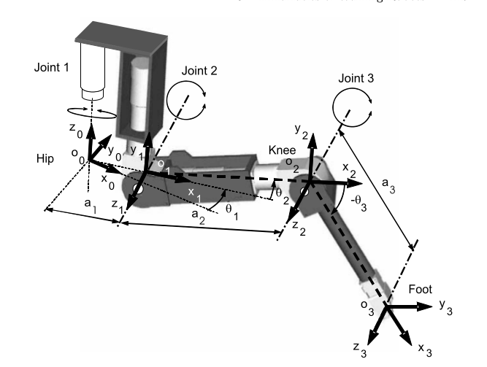

D-H parametrs for the SILO4 leg:
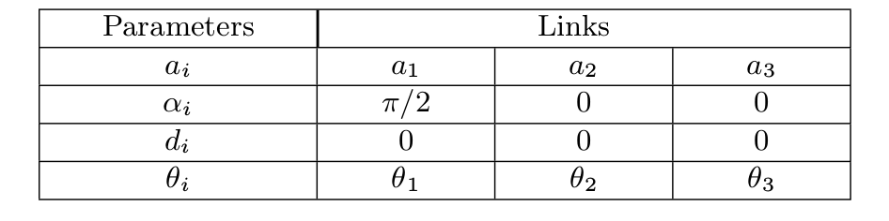
Homogeneous Transformation Matrix :
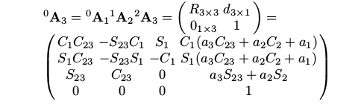

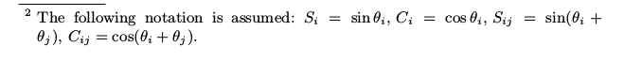
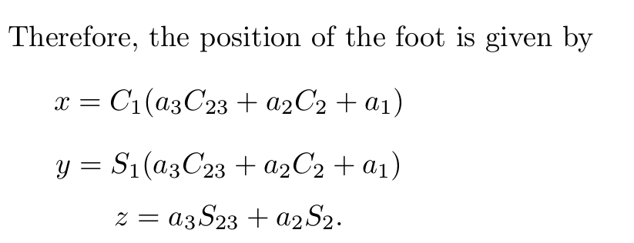

Inverse Kinematics:

Solving for θ ₁, θ ₂, θ ₃

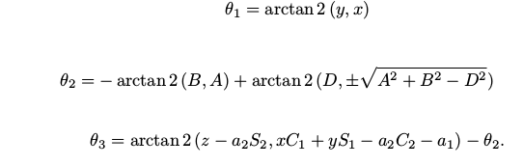

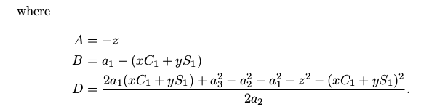

Dynamics of Walking Robots

The equation of motion of a system with m legs and n DOFs is given by:

τ is the vector of joint torques τ ∈ R^{n×m}
F is the vector of ground contact forces F ∈ R^{m×3}
D is the mass matrix D ∈ R^{n×m+6 , n×m+6}
H denotes coriolis and centrifugal effects H ∈ R ^{n×m+6}
C denotes gravitational effects C ∈ R^{n×m+6}
q is the vector of generalized coordinates q ∈ R^{n×m+6}
J_{m} and J_{f} denote the projection of torques and forces to a point q J_{M} ∈ R ^{n×m,n×m+6},
J_{f} ∈ R^{n×m,n×m+6}

Computing the above equations of motion is extremely time-consuming. Lagrange-multipliers method is used to solve such system of equations.

A robotic leg can be studied from the dynamics point of view as a 3-DOF manipulator with a foot as end-effector.
The dynamic model of a manipulator consists of the model of the mechanical part and the model of its actuators and transmission systems.
The dynamic model of the mechanical part states the mathematical relationships between manipulator motion and the forces and torques causing it.
On the other hand, the dynamic model of actuators and transmission systems finds relationships between control signals and forcesand torques required for motion.

Dynamic Model of the Mechanical Part:
Systematic derivation of the Lagrange-Euler equations yields a dynamic
expression that can be written in the form

Dynamic Model of Actuators and Transmission Systems:

Generally we have 3 types of actuators – electric, pneumatic and hydraulic.
Electric actuators are more precisely controlled, however, and thus are more widely used.
In the operation of DC motors, inertia and friction arise during rotor spin that must be balanced through the motor torque. Also, if high reduction gearing is used, as in walking robots, friction, elasticity and backlash are introduced.

Dynamics of SILO4 robot:
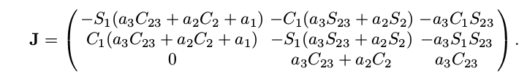

ch. 7 Improving Leg Speed by Soft Computing
Techniques

Walking robots that are designed to work outdoors, on natural ground,
usually need to negotiate obstacles like rocks or trees that can interrupt a
leg’s transfer trajectory. To manage this inconvenience, leg trajectories are
generated on-line, to avoid the computational burden of repeatedly generating
a complete trajectory each time an obstacle has to be avoided. Therefore,
improving leg speed in on-line trajectory generation is required. This chapter is
focused on improving leg velocity for on-line trajectory generation.

The following method is employed to increase leg speed:
The Acceleration Tuning Approach:

It involves 3 steps:
1. Experimental workspace partitioning - Experimental determination of the range of values for the trajectory parameters. That is, trajectory distance, average speed, and acceler-
ation ranges must be identified.
2. Fuzzy sets and rules -The output variable of the fuzzy inference system is the foot acceleration,
which is needed for foot velocity profile determination and thus foot trajectory
generation.
3. Inference map calculation - Inference map of foot acceleration vs trajectory distance and average
foot speed is fond using MATLAB.

Ch. 8 Virtual Sensors for Walking Robots

The relationship between foot forces and joint-position errors
depends on many factors and is consequently determined by a complex pat-
tern. In order to obtain a functional system to estimate foot forces, it is nec-
essary to develop a model that identifies these effects, enabling the unknown
magnitude to be correlated with the available magnitudes. This idea matches
the definition of the virtual sensor

Virtual Sensor:

Virtual sensors, also known as software sensors or estimators, are methods
used to measure sensorial magnitudes indirectly through the analysis of avail-
able related sensorial data.
The following outputs are expected from virtual sensors
1. Classification of the leg state into one of the following options: collision
with terrain or free motion.
2. Estimation of the module of the force exerted by the foot.
3. Estimation of the three foot force components.

Each leg of SILO4 has a force sensor on its end effector. Data from this sensor is introduced as an input in a neural network and the above output is generated.

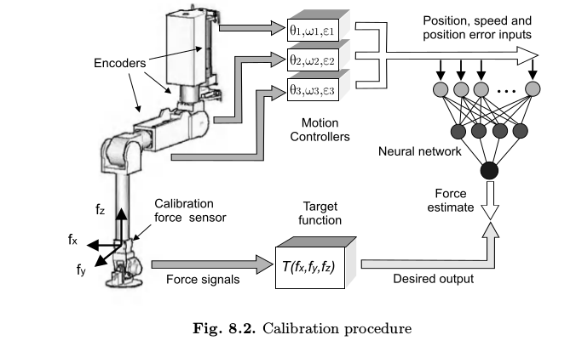

Graphical data of foot sensors is given in the book.

Ch. 9 Human-machine Interfaces

People working on SILO4 created a GUI to communicate with it. This chapter discusses its different features.
The software is not available online.

Appendix - The SILO4 Walking Robot

